The Basics
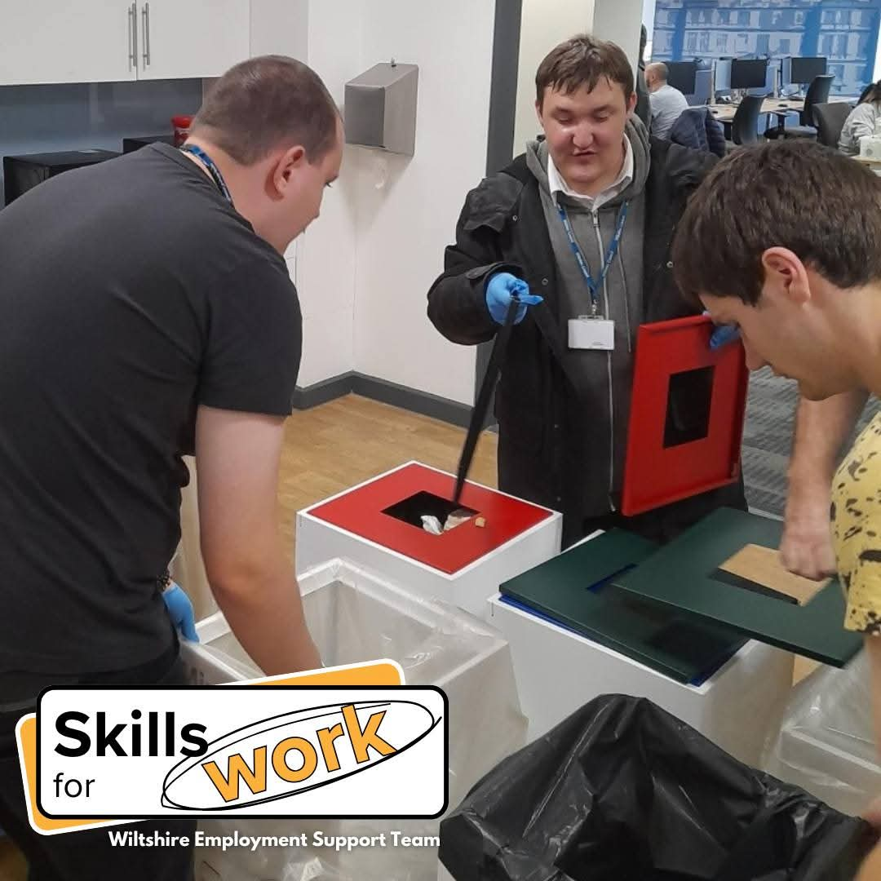
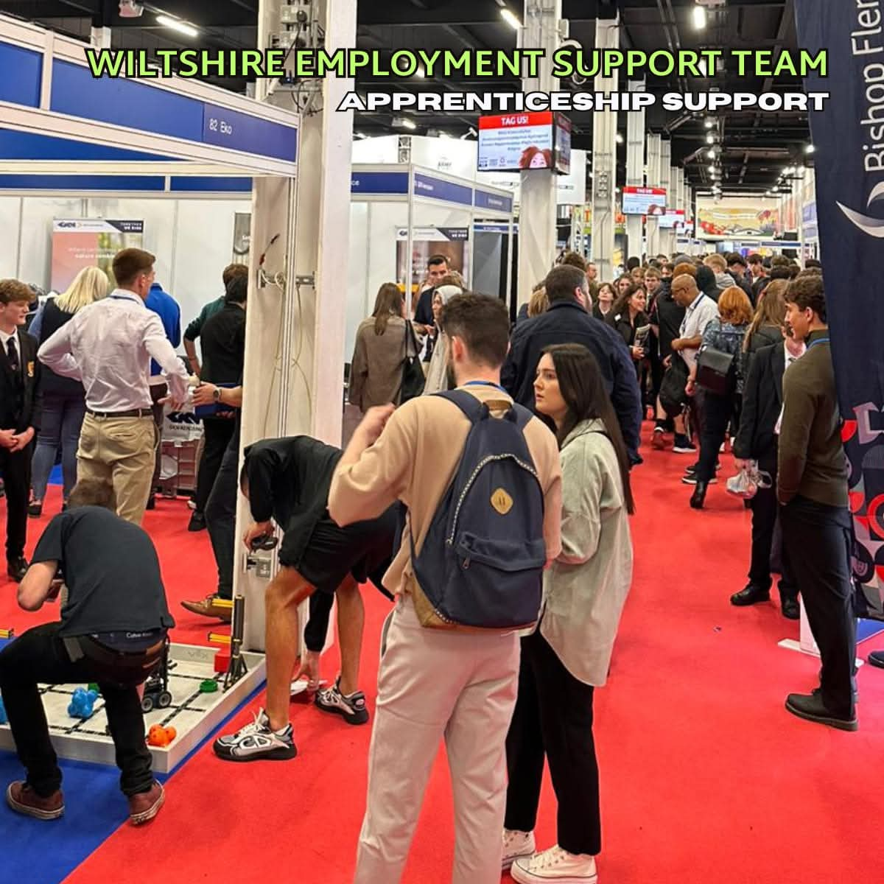
What is a Supported Internship?
A supported internship is a structured, work-based study programme for young people with learning disabilities and/or autism. The goal is to help interns gain skills, confidence, and experience for paid employment.
This pilot programme focuses on specific sectors within Wiltshire Council departments and partner employers in Wiltshire, combining classroom learning, work placements (called working interviews), job coaching and increasing skills and experiences of the workplace.
What’s included
Learning (typically, two days a week at County Hall, Trowbridge. Monday & Tuesday):
- Skills for work: CV writing, interview practice, workplace behaviours
- Functional skills: English, maths, digital literacy
- Personal development: confidence building, communication
- Council training modules + online learning
- The opportunity to gain employer recognised training and a BTEC qualification in Work Skills
A mix of tutor led learning, where a Fairfield College tutor will come to County Hall, and Wiltshire Council job coaches or trainers.
Work Placements (Working Interviews):
- Around 16+ hours/week in council departments or partner employers
- Example progression:
  - Sept–Dec: Customer Services (e.g., reception, admin)
  - Jan–Apr: Leisure reception or Libraries
  - May–June: Longer placement with job-focused tasks
What is important to note: this programme aims to mirror real life examples of work, and working interviews can vary from 6 weeks up to 12 weeks and will not follow standard college times. Weekend, evening or early starts could be needed, dependent on the workplace
On the job support will reduce through the working interview, starting with 100% and reducing to 50%, 25% through to the intern working independently.
Job Coach Support:
- Travel training
- In-role coaching (gradually reduced as independence grows)
- Regular reviews with intern and employer
A job coach gives tailored guidance and practical support to help interns succeed in the workplace. They act as a bridge between the intern and employer, ensuring tasks are understood, skills are developed, and confidence grows.
Additional Opportunities
- Job searching and other various workshops
- Apprenticeship preparation for council roles if that is appropriate
- Sector visits to broaden understanding
- Access to a mentor who works at Wiltshire Council and is becoming an Aspiring Leader
- The chance to organise an event, that enhances organisation, teamwork and a great addition to your CV
Who Can Apply?
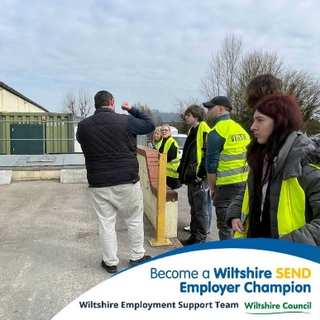
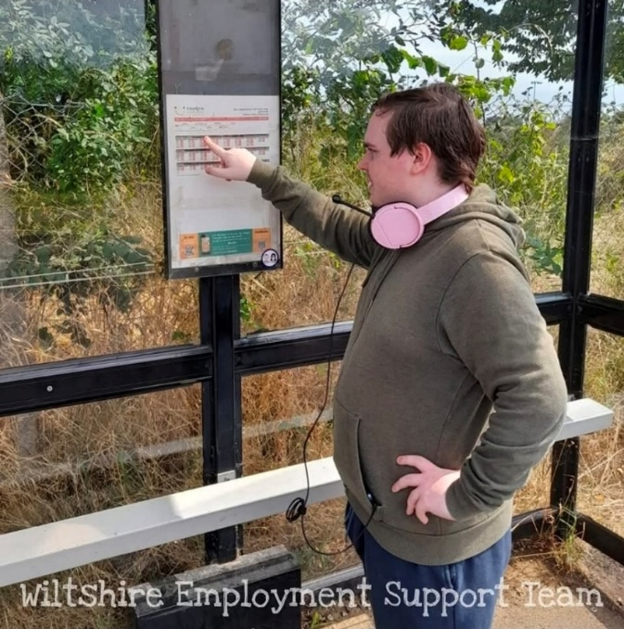
Applicants must:
✔ Be 19 years old by 01 Sept 2026
✔ Have an open EHCP and live in Wiltshire
✔ Demonstrate motivation and commitment to the SI year and the workplace
✔ Be able to travel independently or willing to learn
✔ Have prior work experience (work experience or volunteering)
✔ Most importantly: Want to leave education and get a job.
These points will be assessed via application and interview process, as well as exploring safe behaviours and the willingness to become a reliable employee.
Important Notes
Our program is here to empower young people to build independence, confidence, and real-world skills. It’s not just an extra year of education or a place to pass the time.
Interns must be motivated to work and try new things.
The aim is paid, sustained employment.

Answers to a couple of common questions
This is not a five-day course. It will be devised on an individual basis, employer need and job availability. There will be times that the intern is not needed to attend, especially before or after any working interview starts. Flexibility will be needed to be successful.
The internship year starts in September and runs for a minimum of eight months (finishing in April for some interns) and a maximum of 10 months (June 2027).

Sectors Available
There will be specific sectors on offer with limited spaces. Applicants will be asked to rank preferences at the application stage.
- Customer Service (main focus)
- Health & Social Care
- Facilities Management
- Leisure & Recreation
- Administration & Office Support
Timeline
Monday 19 January Application window opens
Thursday 29 January Information session to find out more about the programme
- 1.30pm to 3pm at County Hall, Trowbridge
- 5pm to 6.30pm at County Hall, Trowbridge
Please contact charlotte.rean@wiltshire.gov.uk our business admin assistant to book a spot
Friday 13 February Application window closes at 5pm
Week of 16 February Review panel of applications for interview spaces
Friday 20 February Interview invites, or rejection information will be sent
03 and 05 March Interviews
By 31 March Places will be offered
September 2026 Internship year starts
To get an application form for this programme please contact admissions@ffc.ac.uk
or supportedinternships@wiltshire.gov.uk

