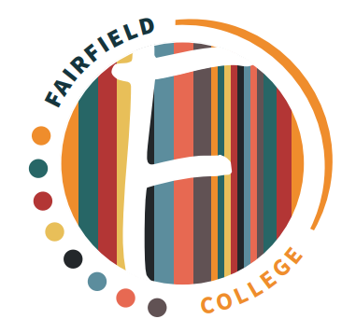

Careers Strategy
Issued: September 2026
Review: September 2027

Mission Statement:
To enable young people to live and work without barriers.

There has never been a time when careers guidance has been as important for young people as it is today. Fairfield College has a critical role to play in preparing learners for the next stage of their education, training or employment pathways.
The Special Educational needs and disability code of practice 0 - 25 years January 2015 identifies - Colleges and schools should raise the career aspirations of their SEN learners and broaden their employment horizons. They should use a wide range of imaginative approaches, such as taster opportunities, work experience, mentoring, exploring entrepreneurial options, role models and inspiring speakers.
Career related goals may come in different guises for young people with learning difficulties, but they are all equally valid to the individual and their family. ‘Careers’ must be viewed in a wider context and more holistically to include the elements of ‘Preparing for Adulthood’. For this reason, at Fairfield College, we focus on preparing learners in four specific areas:
- Work/employment and further education.
- Independent living and living skills.
- Community friends and relationships.
- Good health.
Fairfield College has a Careers Strategy and belief that all learners, regardless of their educational needs, can make positive and meaningful contributions to society, whether this is through paid work, voluntary work, part or full time or through joint community enterprise activities which benefit the local community.
With the greater choices of education, training and employment, our aim is to prepare learners for these ever-changing opportunities, responsibilities and experiences and to equip them with the skills to manage the choices, changes and transitions ahead of them.
In December 2017, the Department for Education released its new career guidance strategy and introduced the Gatsby Benchmarks that set out a mechanism to ensure high-quality careers and enterprise provision. Careers provision became part of Ofsted inspection framework in September 2019. Fairfield College employs an Employment Manager/Careers Leader to implement, lead on and oversee the Careers Programme and ensure that Fairfield College is working towards the Gatsby Benchmarks.
The Gatsby Benchmarks have been revised for 2025. These updates, published in May 2025 and effective from September 2025, aim to ensure the framework remains relevant in the face of technological advancements, educational innovation, and labour market shifts. The core principles of the benchmarks remain, but there are key changes across several areas:
Careers at the heart of education and leadership: Integrating careers guidance more fully into the curriculum and leadership structures.
Inclusion and impact for each young person: Ensuring equitable access to quality career guidance for all students, regardless of background or circumstance.
Meaningful and varied encounters and experiences: Emphasizing the importance of well-planned and impactful interactions with the world of work.
Focusing on the use of information and data: Encouraging the use of data to track progress, evaluate effectiveness, and personalize guidance.
Engagement of parents and carers: Recognizing the crucial role of parents and carers in supporting young people's career choices
The Gatsby Benchmarks set out a framework for schools and colleges to deliver ‘good careers guidance’:

1. A stable careers programme
2. Learning from career and labour market information
3. Addressing the needs of each pupil
4. Linking curriculum learning to careers
5. Encounters with employers and employees
6. Experiences of workplaces
7. Encounters with further and higher education
8. Personal guidance

As set out in the Department for Education’s Careers Strategy Fairfield College is required to have a designated member of staff named as Careers Lead, supported by the College Leadership Team. The Careers Lead will have responsibility to ensure Fairfield College meet mandatory requirements and work towards achieving all eight Gatsby Benchmarks. Darren Barber (Employment Manager & Careers Leader) undertakes this role and has completed the level 6 Careers Leader qualification and the level 6 Career Guidance and Development qualification.
Fairfield College embeds careers education into our curriculum and work-based learning areas taking a whole college approach. At Fairfield learners develop themselves and their skillset through work-based learning, work experience, vocational subjects, independence skills, personal growth & wellbeing and enterprise. Each learner develops employability skills whilst at Fairfield College. Learners on the Work Skills Programme gain a deeper understanding of rights & responsibilities, behaviour at work, interview preparation and take part in a mock interview with real employers.
Our careers programme embeds each of the 8 Gatsby benchmarks and is reviewed on an annual basis considering the views of learners, parents, staff and employers. Fairfield College offers vocational and specialist qualifications that will support the learner journey.
The DFE statutory guidance for schools and colleges published 25th March 2015 and updated 31st August 2022 ‘Careers guidance and access for education and training providers’ states that careers guidance is the full range of activity delivered under the eight Gatsby Benchmarks. This guidance refers to the following legislation:
- Section 42A, 42B, 45 and 45A of the Education Act 1997
- Section 72 of the Education and Skills Act 2008
- Schedule 4 (15) of the School Information (England) Regulations 2008
Every learner at Fairfield College and where suitable has access to impartial advice and guidance from our Employment Manager and once learners are 19+ and where suitable they can receive impartial advice and guidance onsite from the National Careers Service. Each learner has a pathway planning booklet and those learners that have met with the National Careers Service Advisor will receive a personal action plan and usually a CV.
Work based learning and work experience is an important part of the study programme at Fairfield College and the learner journey. Learners that have proven that they are ready are supported to access work experience placements in areas of interest to prepare them for the world of work, future pathways and employment opportunities. Learners are supported on their work experience journey by a designated Fairfield Job Coach.
Fairfield College offers learners two pathways’ skills for life or skills for work. These pathways are based on learners EHCP outcomes and academic level. Skills for life learners work towards the principals of RARPA whereas Skills for Work learners undertake a BTEC qualification and functional skills maths and English. Skills for life learners primarily undertake work-based learning as part of their programme of study and skills for work learners undertake more external work experience placements as part of their programme of study.
Work Based Learning is provided in a safe and supportive learning environment to meet individual learner needs. Work Based Learning serves a real purpose to Fairfield Trust’s business needs. Work Based Learning Leads, Job Coaches and support staff are available every step of the way to support the learner journey.
Ofsted inspections evaluate careers information, education, advice and guidance under Personal Development and wellbeing. An Ofsted inspection may focus on:
Strategic Leadership and the Gatsby Benchmarks
- Progress Against Benchmarks: Evidence of steady progress toward, or full achievement of, all 8 Gatsby Benchmarks.
- Overarching Strategy: A clear, comprehensive careers strategy that is collaborative, responsive to student needs, and not treated as an isolated provision.
- Website Compliance: A legally compliant and up to date website.
Curriculum Integration and Employability Skills
- Careers in the Curriculum: How effectively subject teachers integrate career concepts, industry insights, and essential skills directly into academic and vocational lessons.
- Skills Alignment: Clear alignment between the student's career aspirations, the knowledge they are learning, and local labour market information (LMI).
High-Quality Work Experience and Employer Engagement
- Workplace Encounters: The frequency and quality of meaningful engagement with employers, alumni, and training providers.
- Work Experience Quality: The organisation and impact of structured work experience and industry placements, ensuring they directly support students' vocational or academic paths.
Inclusion, Equity, and Targeted Support
- Focus on Disadvantaged Groups: Specific, tailored careers support for learners from lower socioeconomic backgrounds, those with special educational needs and disabilities (SEND), and care-experienced students.
- Independence and Aspiration: For SEND students, how well provision prepares them for independent living, supported independence, or further technical study.
- Challenging Stereotypes: Active efforts by the college to challenge gender, racial, or cultural stereotypes in student career paths.
Impact, Destination Data, and Continuous Evaluation
- Sustained Positive Destinations: Robust collection and analysis of student destination data to verify that learners progress into positive, long-term employment, apprenticeships, or higher education.
- Continuous Feedback Loops: Routine gathering of feedback from students, parents, and employers to actively refine, audit, and improve the careers programme over time.

Fairfield College therefore must:

- Provide an effective careers programme that offers advice, experience and contact with employers to encourage learners to aspire, make good choices and understand what they need to do to reach and succeed in their chosen career.
- Support readiness for the next phase of education, training or employment so that learners can make the transition to the next stage successfully.
- Monitor the quality of careers information, education, advice and guidance, and how well these benefit learners in choosing and deciding on their next steps.
- Continue to grow and foster industry contacts and work experience providers.
- Monitor learner destinations and use this data to refine and develop our career programme.
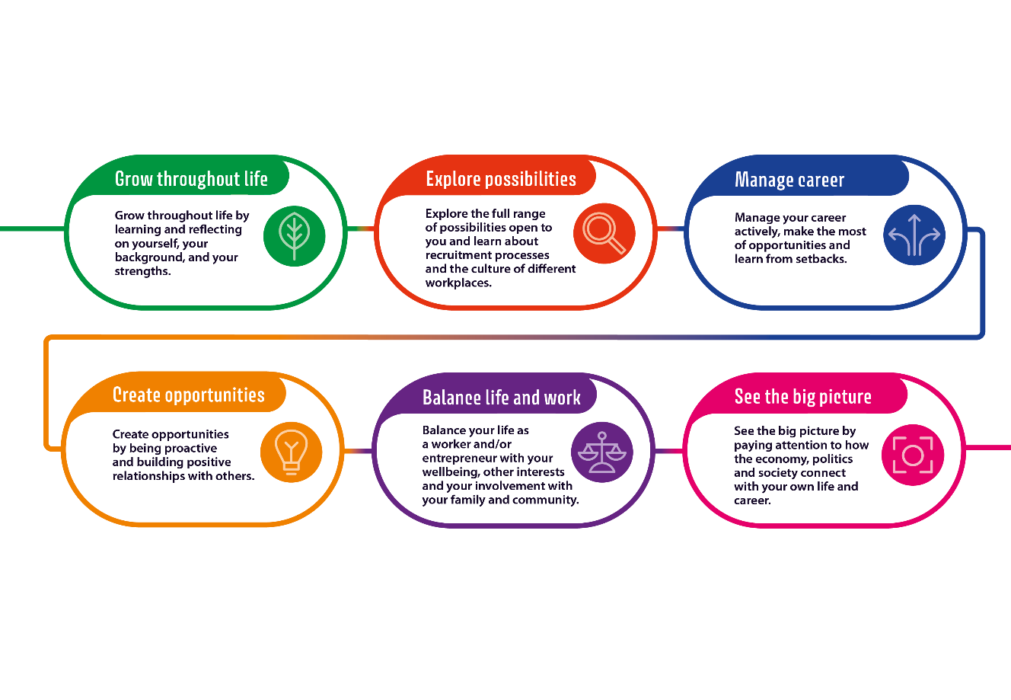
Fairfield College embeds the Careers Development Institute (CDI) ‘Career Development Framework’ by giving learners the opportunity to learn and develop their strengths, to explore what possibilities are available to them, to make the most of their career opportunities, to create opportunities and build positive relationships, to learn about balancing life and work and to see the bigger picture in society and how they fit within it.

Talentino developed the ‘Same and Different’ model that enables careers practitioners, employers, families and others to better understand the aspects of early career development for 18-year olds with SEND. All aspects underpin the delivery of the Gatsby Benchmarks, and they are categorised in three ways:
- Same – this is an aspect that will have the same value to a young person with SEND as to those without SEND
- Same and Different – this is an aspect that will have the same value to a young person with SEND but will need to be delivered differently
- Different – these aspects will only be relevant to the young person with SEND and will not be relevant to young people without SEND.
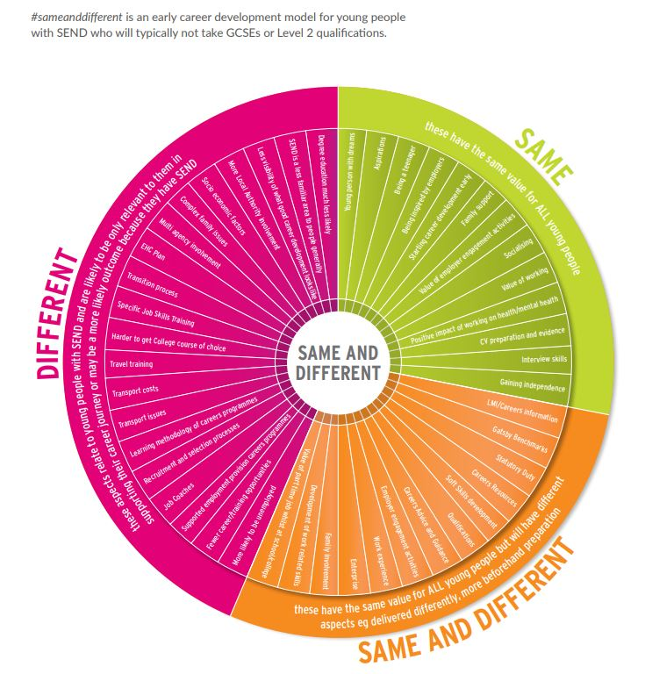
This model can be used to support understanding with all stakeholders around young people with SEND.
https://www.talentinocareers.co.uk/same-and-different.pdf
With the government’s reforms to technical education and skills and the impact of COVID-19 on the labour market, there will be an increasing need for schools and colleges to work in partnership with employers, careers advisers, local authorities and other education and training providers to support students to prepare for the workplace and to make informed choices about the next step in their education or training.
To support this, the DFE has funded The Careers & Enterprise Company to support schools and colleges to develop careers programmes in line with their career’s requirements and the Gatsby Benchmarks. Fairfield College is part of the Swindon and Wiltshire Careers Hub and the lead provider for SEND in Wiltshire and Swindon.
Fairfield College evaluates its performance against the Gatsby Benchmarks termly using the Compass Tool developed by the Careers and Enterprise Company and submits its performance percentages.
Fairfield College learners take part in a careers provision survey on an annual basis and staff, employers, parents and stakeholders on a two-year basis. The findings from these surveys help us evaluate, modify and improve our careers provision.
Fairfield College engages with parents and carers by sending them their young person’s pathway planning booklet prior to annual EHCP reviews, inviting parents/carers to our annual leavers transition fair, sending regular college careers newsletters, Social media updates and LMI updates.
Fairfield College 2026-2027 Careers Programme will aim to raise the aspirations of all learners whilst being tailored to individual needs. The programme will inform learners of the range of opportunities available to them, encouraging them to aim higher and make choices relevant to what they feel they can achieve. All forms of stereotyping will be prohibited in careers advice and guidance that is provided to learners. Fairfield College learners will have the opportunity to take part in a range of career related activities, employer engagements and work-based learning and work experiences.
Learners attending Fairfield College on the Skills for work pathway will study for a BTEC qualification in either Hospitality & Tourism, Land based Studies, Animal Care or Horticulture alongside functional skills maths and English.
Fairfield College delivers BTEC qualifications to provide learners with a career focussed, industry recognised qualification that enables learners to develop and apply the knowledge, skills and behaviours that employers or Further education or training providers are looking for.
Additional standalone qualifications such as basic food hygiene will be offered to individual learners that need additional qualifications for their programme of study or work experience placement.
Students on the skills for life pathway will undertake a RARPA qualification linked to their individual EHCP outcomes.
Each student will have several careers related outcomes linked to their study programme or pathway.
Below is a breakdown of the knowledge, skills development & careers activities on offer as part of Fairfield College careers programme and the impact this will have on our learners:
Intent: | Fairfield College has a careers strategy and belief that all learners, regardless of their educational needs, can make a positive and meaningful contribution to society, whether this is through paid work, voluntary work, part time or full time or through joint community enterprise activities which benefit the community. With the greater choices of education, training and employment, our aim is to prepare learners for these ever-changing opportunities, responsibilities and experiences and to equip them with the skills to manage the choices, changes and transitions ahead of them.

Implementation: | Skills for Life | Skills for Work
Knowledge | - Develop skills and gain experiences in WBL areas.  - Find out about different kinds of jobs and what different organisations do.  - Learn about themselves and their strengths.  - Learn about developing positive relationships.  - Learn about expected behaviour at work.  - Be able to recognise different employability skills and recognise their own personal strengths.  - Build independence skills by taking part in offsite travel familiarisation training.  - Give ideas about what they may be able to do for their next steps. | - Be able to recognise different employability skills and recognise their own personal strengths.  - Start to build networks by accessing work experiences offsite.  - Start to think about career choices or next steps and give realistic ideas.  - Build resilience and overcome challenges. Model the behaviour expected for work.  - Actively look at what job opportunities are available in the local area.  - Learn about different jobs that may suit them.  - Build independence skills by taking part in offsite travel familiarisation training.  - Work with the Job Coach team to explore a work experience placement that links to their study programme or future aspirations.  - Experience an interview with a real employer.  - Learn about rights and responsibilities.  - Be prepared for those next steps when education ends.
Skills Development | Students will work across the curriculum to develop the essential skills for life: Listening, speaking, problem solving, creativity, staying positive, aiming high, leadership, teamwork
Careers Activities on offer at Fairfield College | Employer Engagement Morning, Work Based Learning, Personal Guidance meetings, Platform Rail Safety workshops, GWR travel training, Student Next Steps evening.  For leavers: College alumni morning, moving on sessions. | Employer Engagement Morning. Offsite work experience, GWR travel training, Careers fairs, Personal Guidance meetings, mock interviews, Student Next Steps evening.  For leavers: College alumni morning, moving on sessions. The Big Interview event.

Impact: | - Learners have developed key employability skills.  - Learners have demonstrated increased confidence and competence in real world settings.  - Learners can demonstrate appropriate behaviour at work.  - Learners begin to identify what strengths and skills they may have.  - Learners can carry out job tasks more independently. | - Learners can transfer key skills learned in WBL to offsite WEX.  - Learners can consistently and confidently demonstrate the behaviours required for work.  - Learners can confidently communicate with people from the world of work.  - Learners feel more confident of being offsite and outside of college.  - Learners can identify potential next steps or career choices.  - Learners have a greater understanding of themselves and who they want to be.  - Learners can confidently express their key skills and strengths.  - Learners can talk about themselves and their experiences to others.  - Learners are confident to find out what it out there and network at events.  - Learners are confident to make their voice heard to parents and professionals.

Fairfield College keeps comprehensive and accurate records to support the career development of learners. Each learner’s world of work journey is captured and tracked in a career’s tracker held by our Employment Manager.
Destination data is retained where possible for each learner by Fairfield College for a three-year period.
Fairfield College staff will take part in relevant careers related CPD during staff training days and complete any relevant courses or qualifications linked to careers education and provision.
Fairfield College 2026-2027 Objectives:
Gatsby Benchmark 1: A Stable Careers Programme
- Update careers strategy to include parental engagement (e.g. online workshops, newsletters).
- Launch a dedicated parent area on the career’s section of the Fairfield College website.
- Share our careers programme and strategy with all stakeholders at the start of the academic year.
- Add career learning outcomes to student tracker.
- Commission visual careers roadmap materials.
- Continue collaboration with Swindon & Wilts Careers Hub.
- Ensure the careers programme is delivered by individuals with the right skills and experience. Fairfield College will use qualified careers professionals to offer advice and guidance to all students during their time at college.
- Enable students to understand the range of opportunities available to them, the skills that are valued within the workplace and to have first-hand experience of a work environment.
- Develop and publish a careers programme that will raise the aspirations of all students regardless of academic ability and is tailored to meet their individual needs wherever possible.
- Ensure our Careers Strategy is fully supported by the Senior Leadership Team within the college and is approved by the board of Trustees.
- Ensure there is a clear focus on the activities which support enterprise, employability skills, workplace experiences and qualifications which employers’ value.
- Regularly evaluate our careers programme to determine the impact of our career-related activity based on the feedback provided to us by students, staff, employers and parents/carers.
- Maintain high-quality careers provision endorsed by the Careers and Enterprise Company and review the improvement of our programme by using Compass evaluation and Tracker tools.
- Direct stakeholders to the college website information linked to careers.
Gatsby Benchmark 2: Learning From Career and Labour Market Information
- Continue to deliver LMI CPD sessions for college education staff and make sure staff are aware of any changes to the current labour market.
- Share LMI data with parents and staff via newsletters and social media.
- Host an LMI training session for parents/carers.
- Promote pathways like Community Connecting, WEST, Connect to work.
- Provide careers information directly to parents/carers.
- Encourage parents/carers to engage with the college website where key information is presented.
- Actively share labour market information with parents/carers via email or social media channels.
Gatsby Benchmark 3: Addressing The Needs of The Pupil
- Provide careers related information to student EHCP reviews.
- Ensure that a programme of activity takes place which raises the aspirations of all students and challenges stereotypical thinking in terms of equality and gender.
- Record aspirations and destinations and track three-year destination data for each student where possible.
- Continue tracking destinations wherever possible. Use destination data to identify trends and progression routes.
- Bring back alumni students to share their success stories and inspire current students. Update alumni board annually.
- Request careers activity for new students joining Fairfield from their previous school/college.

Gatsby Benchmark 4: Linking Curriculum Learning to Careers
- Display job profiles in tutor/WBL rooms (audit needed).
- Deliver careers and Gatsby Benchmarks CPD to all new staff.
- Ensure any new staff complete CEC certified careers training.
- Encourage subject staff to build industry links.
- Ensure that subject tutors across the whole college support the delivery of careers education and guidance and can link the content of curriculum with careers, even in sessions which are not specifically occupation led. Subject specialist staff can be powerful role models to attract students towards their field and the careers that flow from it.
- Ensure that careers related activities are built in throughout the school year and not just towards the end of any given topic / subject being delivered.
- Encourage subject staff to offer students an employer encounter linked to their subject each academic year.
- Encourage subject staff to develop and tap into industry contacts.
Gatsby Benchmark 5: Encounters with Employers and Employees
- Ensure each employer encounter has a pre-agreed learning outcome.
- Log each employer encounter in the employer encounter log so that we have a record.
- Subject staff to lead one employer encounter linked to their area.
- Increase the number of activities which are conducted within college with the support of local employers.
- Ensure that students can improve employability skills and their understanding of and awareness of the world of work.
- Provide opportunities for learners to visit careers fairs and moving on events to gain a greater understanding of the world of work.
- Provide learners with an annual employer engagement morning where learners can meet employers from the world of work and take part in employer led activities. All learners will have a minimum of two employer encounters each academic year.
Gatsby Benchmark 6: Experiences of the Workplace
- Ensure every learner experience work-based learning or a work placement. Work experience should be meaningful and align with the learners interests and aspirations or college courses.
- Explore virtual work experience opportunities.
- Provide learners on work placement and the employer with support from our well-trained and experienced Job Coach team.
- Strengthening our links with local employers.
- Embed the Careers & Enterprise Companies new equalex work experience framework into our world of work agreements and work placements. This will enable pre-agreed learning outcomes.
Gatsby Benchmark 7: Encounters with Further and Higher Education
- Host WEST sessions on employment routes (October 2025).
- Organise apprenticeship workshops with Mike Loveday.
- Attend Apprentifest (if held locally) and arrange college tours as needed.
- Provide students and parents where applicable with information about further study options post Fairfield College.
- Support learners with any college applications, visits and inductions.
Gatsby Benchmark 8: Personal Guidance
- Update website with careers guidance information.
- Ensure all learners (except students in their first year of study on skills for life) have a careers meeting with a professional and level 6 qualified impartial careers adviser each academic year.
- Schedule monthly sessions with the National Careers Service for 19+ learners.
- Share pathway planner with parents after guidance meetings.
Please see the ‘Fairfield College Careers Programme September 2026 to July 2027’ document for the range of careers activities on offer and how each activity links to the Gatsby Benchmarks.
Please see the ‘Fairfield College Work Experience Guidance’ for more details relating to work experience placements.
Destination Data 2023-2025:
Destination | 2024 (%) | 2025 (%) | 2026(%)
Paid Work | 12% | 21% | 22% (expected within 12 months
Voluntary Work | 12% | 10% | 2%
Supported Internship | 0% | 0% | 14%
Further Education | 10% | 10% | 19%
Social Care Provision | 52% | 43% | 29%
STEPs Programme | 14% | 17% | 14%

When you compare that the national statistic of people with a learning disability in paid employment is 4.8% then Fairfield College student destinations are strong in the employment outcome field. We work closely with Wiltshire Employment Support Team (WEST) who work with our leavers who are ready to move into paid work and provide Job Coach support to help the young person apply for jobs, attend interviews, travel training and then support the young person and the employer until they feel they are at the stage where they can fade out the support. We encourage our alumni to come back to college and talk about their success within the world of work.
Many college leavers move on to local authority social care provision which may include work placements with organisations such as Shaw Trust Palmer Gardens, Able Hands Together Community Farm and Larkrise Community Farm.
Some leavers work with Wiltshire Council service Community Connecting to find Volunteering opportunities locally. This has also led to paid employment for some alumni.

